Lab # 10

# OBJECTive

Define the concepts of loop in assembly language

**LOOP**

A loop is a sequence of instructions that is repeated. The number of times to repeat may be known in advance, or it may depend on conditions i.e. it’s a count controlled loop.

**KEYWORD: LOOP**

A FOR loop is implemented using the LOOP instruction. The counter for the loop is the CX register, which is initialized to loop count, which is the number of times the loop is executed. Execution of the LOOP instruction causes CX to be decremented automatically. If CX becomes 0,the next instruction after loop is done.

**Syntax: Loop label**

* The Loop instruction decrements CX without changing any flags
* If CX is not zero after the decrement, control is transferred to the destination label
* The jump is a SHORT jump only

**More Loop Instructions:**

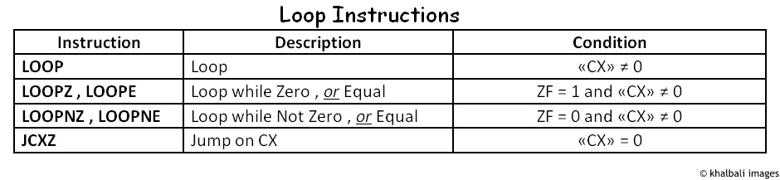

**Example:** To display ‘5’ for five times using loop keyword

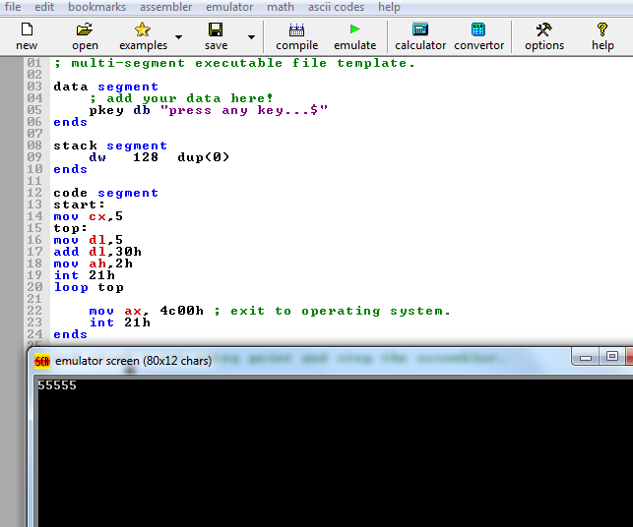

**EXERCISE: (only use loop instructions)**

**Task#01:** Write a program to print ‘*’ 100 times using linefeed and carriage return

**Task#02:** Write a program to print ASCII characters**.**

**Task#03:** Write a program to print your name 10 times using linefeed and carriage return.